*Getting Started User Guide  
Ver. 1.0  
Date: 05/15/2019  
Author: Raffi Tchakmakjian*

Getting Started User Guide

When you first start the app, you’ll see the following screen:

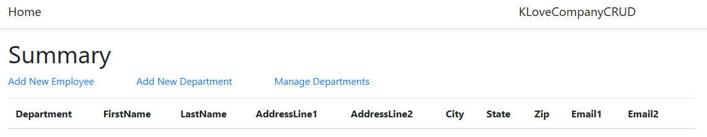

You can not create an employee without creating at least one department first. You will get a message on the screen telling you to select a department (doesn’t exist yet) or create one.

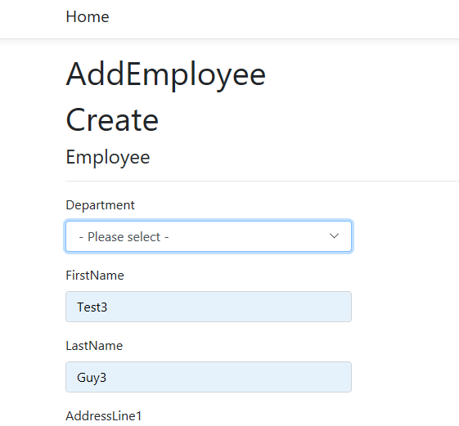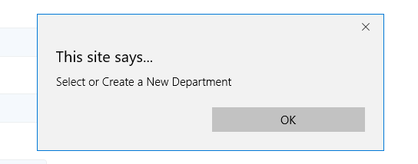

To create a new department, click on the ‘Add New Department’ link from the Summary screen. This will take you to the department creation screen:

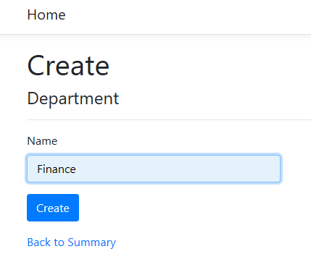

Once you click Create, you will be returned to the departments overview screen. Click on the ‘Back to Summary’ link to return back to the Summary screen. You can now proceed to create the first employee.

Click on ‘Add New Employee’ to view the Employee creation screen and select a department from the dropdown.

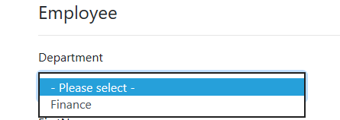

Fill out the remaining fields and click the Create button to create the employee record. The application will return to the Summary screen showing the newly created employee:

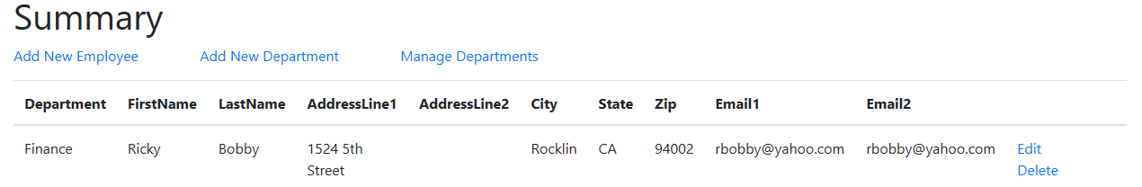

Please ignore the fact I forgot to include a phone number field ☺ We can submit a defect for that for now.

To edit an existing employee record, click on the Edit link from the Summary screen next to the record you wish to edit. If there is more than one deparment, the deparment may be updated to another available department as well .

Once the appropriate edits are made, click the Update button on the bottom of the screen. The Summary screen will be shown with the updated values in the record.

To delete an employee record, click on the Delete link to the right of the desired record. The screen will refresh with the record no longer displayed in the list.

To manage departments, click on the ‘Manage Departments’ link above the employee records.

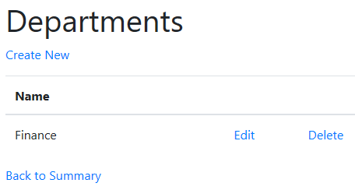

From the Departments landing page, you can create a new department, edit an existing department, and delete an existing department. Edited deparment names will be reflected on the Summary screen. When a department is deleted, any employee records which were associated to the deleted department will also be deleted.